***UNIT---I: INTERNET OF THINGS***

***Introduction to Internet of Things (IoT) – Set 1***

IoT stands for Internet of Things. It refers to the interconnectedness of physical devices, such as appliances and vehicles, that are embedded with software, sensors, and connectivity which enables these objects to connect and exchange data. This technology allows for the collection and sharing of data from a vast network of devices, creating opportunities for more efficient and automated systems.

**Internet of Things (IoT)** is the networking of physical objects that contain electronics embedded within their architecture in order to communicate and sense interactions amongst each other or with respect to the external environment. In the upcoming years, IoT-based technology will offer advanced levels of services and practically change the way people lead their daily lives. Advancements in medicine, power, gene therapies, agriculture, smart cities, and smart homes are just a few of the categorical examples where IoT is strongly established.

IOT is a system of interrelated things, computing devices, mechanical and digital machines, objects, animals, or people that are provided with unique identifiers. And the ability to transfer the data over a network requiring human-to-human or human-to-computer interaction.

# *Internet of Things - Overview*

IoT systems allow users to achieve deeper automation, analysis, and integration within a system. They improve the reach of these areas and their accuracy. IoT utilizes existing and emerging technology for sensing, networking, and robotics.

IoT exploits recent advances in software, falling hardware prices, and modern attitudes towards technology. Its new and advanced elements bring major changes in the delivery of products, goods, and services; and the social, economic, and political impact of those changes.

AD

## **IoT − Key Features**

The most important features of IoT include artificial intelligence, connectivity, sensors, active engagement, and small device use. A brief review of these features is given below −

* **AI** − IoT essentially makes virtually anything “smart”, meaning it enhances every aspect of life with the power of data collection, artificial intelligence algorithms, and networks. This can mean something as simple as enhancing your refrigerator and cabinets to detect when milk and your favorite cereal run low, and to then place an order with your preferred grocer.
* **Connectivity** − New enabling technologies for networking, and specifically IoT networking, mean networks are no longer exclusively tied to major providers. Networks can exist on a much smaller and cheaper scale while still being practical. IoT creates these small networks between its system devices.
* **Sensors** − IoT loses its distinction without sensors. They act as defining instruments which transform IoT from a standard passive network of devices into an active system capable of real-world integration.
* **Active Engagement** − Much of today's interaction with connected technology happens through passive engagement. IoT introduces a new paradigm for active content, product, or service engagement.
* **Small Devices** − Devices, as predicted, have become smaller, cheaper, and more powerful over time. IoT exploits purpose-built small devices to deliver its precision, scalability, and versatility.

## **IoT − Advantages**

The advantages of IoT span across every area of lifestyle and business. Here is a list of some of the advantages that IoT has to offer −

* **Improved Customer Engagement** − Current analytics suffer from blind-spots and significant flaws in accuracy; and as noted, engagement remains passive. IoT completely transforms this to achieve richer and more effective engagement with audiences.
* **Technology Optimization** − The same technologies and data which improve the customer experience also improve device use, and aid in more potent improvements to technology. IoT unlocks a world of critical functional and field data.
* **Reduced Waste** − IoT makes areas of improvement clear. Current analytics give us superficial insight, but IoT provides real-world information leading to more effective management of resources.
* **Enhanced Data Collection** − Modern data collection suffers from its limitations and its design for passive use. IoT breaks it out of those spaces, and places it exactly where humans really want to go to analyze our world. It allows an accurate picture of everything.

## **IoT − Disadvantages**

Though IoT delivers an impressive set of benefits, it also presents a significant set of challenges. Here is a list of some its major issues −

* **Security** − IoT creates an ecosystem of constantly connected devices communicating over networks. The system offers little control despite any security measures. This leaves users exposed to various kinds of attackers.
* **Privacy** − The sophistication of IoT provides substantial personal data in extreme detail without the user's active participation.
* **Complexity** − Some find IoT systems complicated in terms of design, deployment, and maintenance given their use of multiple technologies and a large set of new enabling technologies.
* **Flexibility** − Many are concerned about the flexibility of an IoT system to integrate easily with another. They worry about finding themselves with several conflicting or locked systems.
* **Compliance** − IoT, like any other technology in the realm of business, must comply with regulations. Its complexity makes the issue of compliance seem incredibly challenging when many consider standard software compliance a battle.

# Architecture of Internet of Things (IoT)

Internet of Things (IoT) technology has a wide range of applications and the use of the Internet of Things is growing so faster. Internet of Things (IoT) is the networking of physical objects that contain electronics embedded within their architecture to communicate and sense interactions amongst each other or to the external environment. In this article, we are going to discuss the architecture of the Internet of Things.

## Architecture of IoT

The architecture of IoT is divided into 4 different layers i.e. Sensing Layer, Network Layer, Data processing Layer, and Application Layer.

* **Sensing Layer:**The sensing layer is the first layer of the [Internet of Things](https://www.geeksforgeeks.org/introduction-to-internet-of-things-iot-set-1/) architecture and is responsible for collecting data from different sources. This layer includes [sensors](https://www.geeksforgeeks.org/sensors-in-internet-of-thingsiot/) and [actuators](https://www.geeksforgeeks.org/actuators-in-iot/) that are placed in the environment to gather information about temperature, humidity, light, sound, and other physical parameters. Wired or wireless communication protocols connect these devices to the network layer.
* **Network Layer:**The network layer of an IoT architecture is responsible for providing communication and connectivity between devices in the IoT system. It includes protocols and technologies that enable devices to connect and communicate with each other and with the wider internet. Examples of network technologies that are commonly used in IoT include [WiFi,](https://www.geeksforgeeks.org/what-is-wi-fiwireless-fidelity/" \t "_blank) Bluetooth, Zigbee, and cellular networks such as 4G and [5G technology](https://www.geeksforgeeks.org/5g-technology-and-its-significance/). Additionally, the network layer may include [gateways](https://www.geeksforgeeks.org/introduction-of-gateways/) and [routers](https://www.geeksforgeeks.org/introduction-of-a-router/)that act as intermediaries between devices and the wider internet, and may also include security features such as encryption and authentication to protect against unauthorized access.
* **Data processing Layer:**The data processing layer of IoT architecture refers to the software and hardware components that are responsible for collecting, analyzing, and interpreting data from IoT devices. This layer is responsible for receiving raw data from the devices, processing it, and making it available for further analysis or action.The data processing layer includes a variety of technologies and tools, such as data management systems, analytics platforms, and [machine learning](https://www.geeksforgeeks.org/ml-machine-learning/) algorithms. These tools are used to extract meaningful insights from the data and make decisions based on that data. Example of a technology used in the data processing layer is a data lake, which is a centralized repository for storing raw data from IoT devices.
* **Application Layer:**The application layer of IoT architecture is the topmost layer that interacts directly with the end-user. It is responsible for providing user-friendly interfaces and functionalities that enable users to access and control IoT devices.This layer includes various software and applications such as mobile apps, web portals, and other user interfaces that are designed to interact with the underlying IoT infrastructure. It also includes middleware services that allow different IoT devices and systems to communicate and share data seamlessly.The application layer also includes analytics and processing capabilities that allow data to be analyzed and transformed into meaningful insights. This can include machine learning algorithms, [data visualization tools](https://www.geeksforgeeks.org/data-visualization-tools/), and other advanced analytics capabilities.

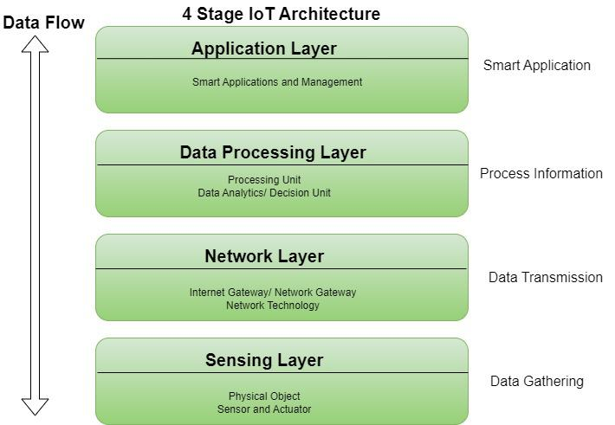

*Architecture of IoT*

## Advantages of IoT

* Execute multiple tasks at a time like a computer.
* Easiest internet connectivity
* Works on [GUI (Graphical User Interface)](https://www.geeksforgeeks.org/what-is-graphical-user-interface/)mode because of [HDMI port.](https://www.geeksforgeeks.org/hdmi-full-form/)
* Best suited for server-based applications i.e., can be connected via [**SSH–Secure Shell**](https://www.geeksforgeeks.org/introduction-to-sshsecure-shell-keys/)-to access the Rpi command line remotely and file sharing via [**FTP–File Transfer Protocol**.](https://www.geeksforgeeks.org/file-transfer-protocol-ftp-in-application-layer/)
* More reliable for software applications.

## Disadvantages of IoT

* Security concerns and potential for hacking or [data breaches.](https://www.geeksforgeeks.org/data-breach/)
* Privacy issues related to the collection and use of personal data.
* Dependence on technology and potential for system failures.
* Limited standardization and interoperability among devices.
* Complexity and increased maintenance requirements.
* High initial investment costs.
* Limited battery life on some devices.
* Concerns about job displacement due to automation.
* Limited regulation and legal framework for IoT, which can lead to confusion and uncertainty.

## **Modern Applications of IoT**

* Smart Grids and energy saving
* Smart cities
* Smart homes/Home automation
* Healthcare
* Earthquake detection
* Radiation detection/hazardous gas detection
* Smartphone detection
* Water flow monitoring
* Traffic monitoring
* Smart door lock protection system
* Robots and Drones
* Healthcare and Hospitals, Telemedicine applications
* Biochip Transponders (For animals in farms)
* Heart monitoring implants (Example Pacemaker, ECG real time tracking)

## Conclusion

The Internet of Things (IoT) is an important technology that allows physical devices to connect and interact with one another and their surroundings via embedded electronics. The IoT architecture, which consists of Sensing, Network, Data Processing, and Application layers, allows for the seamless collecting, analysis, and utilization of data. While IoT provides various benefits, such as increased automation, efficiency, and the capacity to complete multiple jobs at the same time, it also introduces security threats, privacy concerns, and high initial expenses.

## Frequently Asked Questions on Architecture of IoT – FAQs

### Which types of sensors are used in the Sensing Layer?

*Sensors used in the Sensing Layer include temperature sensors, humidity sensors, light sensors, motion detectors, pressure sensors, and gas sensors.*

### How does the Internet of Things protect data security and privacy?

*Encryption, authentication, access control methods, and secure communication protocols all contribute to data security and privacy in the Internet of Things.*

### How do Internet of Things devices control power consumption?

*IoT devices control power consumption using energy-efficient designs, low-power communication protocols, and battery management approaches to increase device durability and reliability.*

*IOT CONNECTIVITY*

**IoT devices are devices that can connect to the internet and communicate with other devices or systems**.[**Examples of IoT devices include**](https://www.bing.com/ck/a?!&&p=251c25a9e543c0c1JmltdHM9MTcxOTc5MjAwMCZpZ3VpZD0yNTFkNjk5Ny1iNTUwLTY4NDUtM2RmZC03ZDlhYjQ1ZTY5NTgmaW5zaWQ9NTkwNQ&ptn=3&ver=2&hsh=3&fclid=251d6997-b550-6845-3dfd-7d9ab45e6958&psq=10+examples+of+iot+devices&u=a1aHR0cHM6Ly8zNjBkaWdpdG1nLmNvbS9ibG9nL3doYXQtYXJlLXRoZS1leGFtcGxlcy1vZi1pb3QtZGV2aWNlcw&ntb=1)[**1**](https://www.bing.com/ck/a?!&&p=12045b56483ae449JmltdHM9MTcxOTc5MjAwMCZpZ3VpZD0yNTFkNjk5Ny1iNTUwLTY4NDUtM2RmZC03ZDlhYjQ1ZTY5NTgmaW5zaWQ9NTkwNg&ptn=3&ver=2&hsh=3&fclid=251d6997-b550-6845-3dfd-7d9ab45e6958&psq=10+examples+of+iot+devices&u=a1aHR0cHM6Ly8zNjBkaWdpdG1nLmNvbS9ibG9nL3doYXQtYXJlLXRoZS1leGFtcGxlcy1vZi1pb3QtZGV2aWNlcw&ntb=1)[**2**](https://www.bing.com/ck/a?!&&p=58086f147f2729f0JmltdHM9MTcxOTc5MjAwMCZpZ3VpZD0yNTFkNjk5Ny1iNTUwLTY4NDUtM2RmZC03ZDlhYjQ1ZTY5NTgmaW5zaWQ9NTkwNw&ptn=3&ver=2&hsh=3&fclid=251d6997-b550-6845-3dfd-7d9ab45e6958&psq=10+examples+of+iot+devices&u=a1aHR0cHM6Ly90ZWxueXguY29tL3Jlc291cmNlcy9pb3QtZGV2aWNlcw&ntb=1):

* Sensors that can measure temperature, humidity, motion, etc.
* Security devices that can monitor and alert for intrusions, fire, smoke, etc.
* Smart home devices that can control lighting, heating, cooling, appliances, etc.
* Smart wearables that can track health, fitness, location, etc.
* IoT medical devices that can monitor vital signs, administer medication, etc.
* Industrial and logistics IoT devices that can optimize production, inventory, transportation, etc.
* Point of Sale devices that can process payments, collect data, etc.
* Personal transportation devices that can navigate, park, charge, etc.

Internet of Things (IoT) is a system of interconnected objects, usually called smart devices, through the Internet. The object can be a heart monitor, a remote, or an automobile with built-in sensors. That is objects that have been assigned an IP address and have the capability to collect and transfer data over a network. The objects interact with the external environment with the help of embedded technology, which helps them in taking decisions. Since these devices can now represent themselves digitally.

*In other words* “The globally ruling technology acts as a single key to shrinking this whole universe to a tiny globally connected village, whereas IoT comprises just two words that precisely depict its definition.”

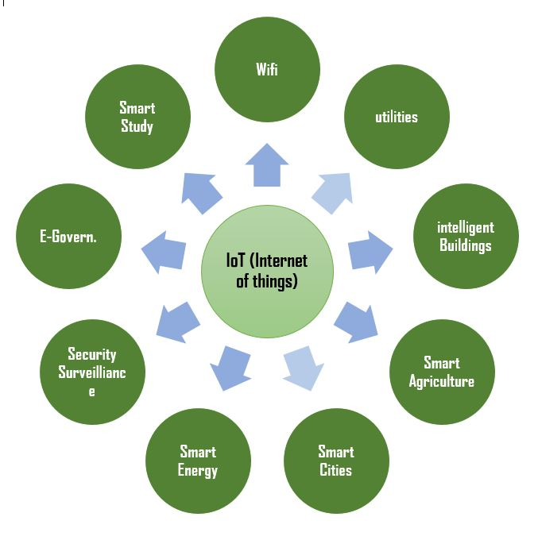

**Internet**: Inter connectivity-For global connection

**+**

**Things**: Embedded system devices-sensors, actuators, RFID tags, QR codes and so many.

* For sensing the data
* Collecting the data
* Sending the data

Thus, on the whole, the Internet of Things is the technology that enables everything to communicate by themselves over the internet through devices without the use of computers. Here comes the most essential and prevalent term in IoT called **‘Smart’** which means ***Automation***– the process of decreasing human intervention or involvement thereby increasing the machine intelligence to perform every task by itself, which could be done by IoT.

IoT makes an intertwined network of artificial things like physical devices, vehicles, home appliances and even to connect with natural living beings like plants, animals, and so on. 

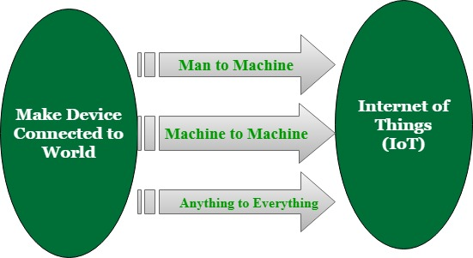

### **Some communication devices in IoT**:

**1. Sensors**: Devices that convert physical parameters like temperature, motion, etc… into electrical signals. Smart sensors are the indispensable enablers of IoT.

*Imagine a scenario of automated monitoring of a farm such that it will just indicate the current situation of crops like “4 crops need water, Now I’m going to pour it” and then it will satisfy the crop’s need.*

This wonder is because of the IoT technology behind it,

1. The temperature sensor connected with the plant pot detects the low temperature.
2. Then it triggers the microprocessor platforms such as Raspberry-Pi, Arduino boards.
3. It receives the sensor signals through internet pathways such as Wi-Fi, Bluetooth.
4. Then it notifies the user and the motion sensor connected to the tap which turns on to pour it.

**2. Actuators**: Devices which is a contrast to sensors. It transforms electrical signals into physical movements. Both sensors and actuators are transducers that convert one form of energy to another. The **exchange of data** is the most important key factor in IoT. Hence sensors and actuators play a vital role here.

**3. RFID Tags**: Wireless microchips are used for automatic ***unique identification*** of anything by tagging it over them. You have been seen it in credit cards, automobile ignition keys, and so on.  
Since interconnection of things is the main goal of IoT, the RFID tags get hand-shaken with IoT technology and are used to provide the unique id for the connected “things” in IoT.

There*are many communication devices and protocols in IoT.*

***Everyone really has numerous questions circling in mind about – How IoT works? What’s behind IoT? What are all the sources of IoT implementation?***

Here we kickstarted few paragraphs on IoT implementation and its working.

### **Some main reasons to make your project as IoT:**

**1. First reason:** (Real-time data) Yes, it’s really important to know this as the first and foremost step to begin.

***Let’s Consider an example:*** If you are going to make an application where there involves a lot of real-time analysis and immediate actions to be performed based on that real-time**data**, then you can opt for your choice of making your project as IoT.

***So what’s that***real-time***data actually means?***

*Assume that you are running the best hotel full of tastiest foods and your regular customer arriving at*11 p.m. *(Hotel’s closing time) has ordered his most favorite dish (naan and paneer butter masala). Unfortunately, the paneer stock had got finished. Thus you are in a situation of rapidly getting and preparing the dish to serve your regular customer. This is the*real-time***analysis****and tackling the situation in a wise manner.*

* **A customer at an** **unexpected time and paneer unavailability**–>real time unexpected data
* **Instant preparation**–>real time analysis and situation tackling

**2. Second reason:** (Intelligent action)

If you wish to lessen the human monitoring and you are most fond of automating everything to make your product/service to be a benchmark, then you can make use of IoT technology.

**Consider an example:***If you are engaged in a peak tensed work and always entering*the *home at late night. To solve this, Imagine your air conditioning system automatically turns on before you have entered the home and makes you cool after your arrival. Then after hearing the sound of opening your house door, the radio system plays your most favorite song and lifts you to the comfort zone.*

The same example suits the IoT’s technical concept too, *consider the smart irrigation system. Assume that it notifies you that “6 crops got the pest attack” (real-time data) so that the action to be performed immediately, hence the fertilizer itself find and spray the crop with the pest attack (automation).*

### **Needs for setting up IoT environment for basic applications**

**1. *Choosing*a** ***platform for IoT development***, which provides a powerful toolkit for IoT development and end-to-end management that connects devices, smart sensors, and IoT gateways to the cloud.

* **AWS IoT:** (Amazon Web Services)
  1. A cloud platform designed for IoT apps with the facility of assuring millions of device connectivity and acts as a data sea.
  2. It supports all SDKs like *Embedded C, Python, and Java*,*etc.*
* **Microsoft Azure IoT:**
  1. Azure cloud platform uses Microsoft Visual Studio SDK.
  2. Collect and analyze real-time device data using a pre-configured remote monitoring system.

**2. Choosing IoT hardware processor:**

**(a) Arduino**

1. Open-source electronics prototyping platform
2. The simplest and the beginner’s choice.
3. To create interactively (IoT) electronic applications
4. It is the first microcontroller based development board
5. Easy to program for beginners by Arduino IDE

***Set up – procedure:***

1. It itself has **0.5KB of the** **boot loader** that makes the program be burned into the circuit.
2. All we have to play with Arduino is to download the Arduino software and start the code.
3. The Arduino programs are called sketches
4. **Basic Arduino language:** C/C++

***Advantages:***

1. Inexpensive
2. Cross-platform/Multiplatform
3. Flexible and easy prototyping
4. Provides pre-wiring and free code libraries
5. More reliable for hardware applications

**(b) Raspberry Pi**

1. Palm-sized computer
2. Constructed with the **educational goal**
3. Easy even for non-technical user
4. Main storage is by SD card
5. Runs on customized Debian Linux called **Raspbian OS**
6. Allows installing all packages such as **Node.js, Python**,**and so on**.
7. It has **4 USB ports** (Universal Serial Bus for data transfer) and **40 GPIO pins** (General Purpose Input/Output pins) to be connected with many peripheral friends.
8. **HDMI port**High Definition Multimedia Interface (to transmit audio and video signals between an HDMI enabled monitor and receiver) to hook up **A/V sources**.

***Set up – procedure:***

1. Any one of the **bootable operating systems** is needed to be written on an SD card using apps.
2. Then **connect the** **display, keyboard, and mouse** to the Pi just like that to make it a normal computer.
3. The Pi supports **video output** which can be hooked to a monitor or even TV using an HDMI port that provides the normal computer’s abilities.
4. Then the necessary **action code** is done with the help of any specified applications.
5. **Basic Raspi language:** python, scratch

***Advantages:***

1. Multiple tasks at a time like a computer
2. Easiest internet connectivity
3. Works on GUI (Graphical User Interface) mode because of HDMI port.
4. Best suited for server-based applications i.e., can be connected via **SSH–Secure Shell**-to access the Rpi command line remotelyand file sharing via **FTP–File Transfer Protocol**.
5. More reliable for software applications.

**3. Need to use Bluetooth beacons:**embedded within the devices to allow IoT objects to broadcast information to the nearby mobile devices so that they can communicate.

**Beacon:**It’s a kind of lighthouse that *repeatedly transmits a single signal to other devices* called a Bluetooth radio transmitter.

**Advantages of IoT:**

|  |  |  |
| --- | --- | --- |
| Communication | Automation | Remote control |
| More information | Better decision | Continuous monitoring |
| Time-saving | Money-saving | Efficient handling |

**Disadvantages of IoT:**

* Lagging of standard compatibility
* More opportunities for failure
* Loss of privacy or security
* More dependent on technology

**Summary:**Thus on the whole Setting up the IoT environment includes,

* Identifying the problem and the purpose.
* Identifying the data collection challenges.
* Identifying the cloud platform for data storage.
* Coding into the processor to meet your expected need after data analysis.
* Enhancing the advantages and diminishing the disadvantages of IoT.

**Applications of IoT:**

**Smart City or Smart Home:** A smart city or a Smart home both sound like something right out of a science fiction book or a show.  
Smart Cities fired up our imagination since the time they were incorporated into the television cartoon The Jetsons. The smart home is supposed to have the following features:-

**Smart kitchen appliances:**– a smart kitchen that would make the house more functional and more appealing to the people buying the house. A few of the features in the smart kitchen include:-

* **Smart plate:-** will be equipped with Wi-Fi, weight sensors, and cameras. The dish will be watching what you eat. If you overload it sends you an alert and it can sync to your personal fitness plan on your mobile.
* **Drop:-**allows the selection of the dish you wish to cook and with the help of a smart scale, you can put together the recipe for your liking. Further, the recipes Drop suggests involving the use of one bowl most of the time. Meaning, it also ensures less cleaning up after cooking.
* **Smart Fridge:-** this would involve an Artificial Intelligence built into the fridge, which could communicate with other devices in the smart kitchen or in the smart home. There’s a 29-inch front screen taking notes or inputting the specifics about the fridge contents.
* **Smart Cooker:-** allows you to adjust your cooking settings like cooking temperature, cook time enabling you to warm up or turn off the device irrespective of where you are – no more burnt breakfast when this comes into the market!!

**Learning Thermostat:** can learn the home owner’s daily timetable and adjust the temperature accordingly

**Smart Lock:**A key-less lock that can be unlocked by means of an application that runs on your smartphone.  
and many more such devices that can make life around your home much easier.

A smart city is an urban system that uses information and communications technology in order to make the infrastructure more interactive make infrastructure more efficient more importantly, make the infrastructure more accessible that is it is available when we need it A smart city is the need of the hour because of:

* A swiftly increasing metropolitan population
* Quickly diminishing store of natural resources
* Environmental and climatic changes

**Now, a smart city shall contain some of these features:**

**Smart Homes:**Smart parking lots- each parking slot shall have an occupancy sensor to sense the presence/absence of a vehicle in that particular slot. A vacant parking space can be chosen by the person wishing to park by simply looking at a mobile application that reflects the status of the parking place smart vehicles smart health, Smart roads, Industrial Automation, Smart retail, and many more…

These are just two of the most common applications of the Internet of things.

**What exactly is the Internet of things?**

It refers to providing network connectivity & computing capabilities to everyday sensors and objects, allowing them to exchange and consume data without any human intervention or with minimal human interference.  
The Internet of things is, thus, a dynamic global network infrastructure with self-configuring capabilities based on standard and interoperable communication protocols where physical and virtual things have identities, physical attributes, and virtual personalities and use intelligent interfaces seamlessly integrated into the information network, often communicate data associated with users and their environment.

**The requirements of building an IoT system are as follows:**

**Dynamic:** IoT systems & devices should have the ability to adapt to changes in the operating conditions on the go.

**Self-Configuring:** This should allow a large number of devices to work together in order to achieve certain functionality.

Should work on interoperable communication protocols in order to facilitate communication between varied devices. Each device in an IoT should have a unique identity that helps in controlling it by means of the Internet Thus, everything that we discussed shall have a sensor built into it (some names reflect it by the word smart attached to them like smart city/smart home).

Smart City and Smart Home are among a few of the revolutionary applications that we can expect out of the Internet of things technology.  
Some of the items described above are about to be launched into the market this year by well-known brands. LG is going to launch a new smart fridge ThinQ which can grant us alerts on when the food stored in it is about to go bad by means of virtual stickers and expiry dates. The Government of India has launched a smart city plan in which many of the smart city features mentioned above will be implemented.

Summer-time is here and so is the time to skill-up! More than 5,000 learners have now completed their journey from **basics of DSA to advanced level development programs** such as Full-Stack, Backend Development, Data Science.   
  
And why go anywhere else when our [DSA to Development: Coding Guide](https://www.geeksforgeeks.org/courses/dsa-to-development-coding-guide?utm_source=geeksforgeeks&utm_medium=article_bottom_text_default&utm_campaign=courses) will help you master all this in a few months! Apply now to our [DSA to Development Program](https://www.geeksforgeeks.org/courses/dsa-to-development-coding-guide?utm_source=geeksforgeeks&utm_medium=article_bottom_text_default&utm_campaign=courses) and our counsellors will connect with you for further guidance & support.

Internet of Things (IoT) is a system of interconnected objects, usually called smart devices, through the Internet. The object can be a heart monitor, a remote, or an automobile with built-in sensors. That is objects that have been assigned an IP address and have the capability to collect and transfer data over a network. The objects interact with the external environment with the help of embedded technology, which helps them in taking decisions. Since these devices can now represent themselves digitally.

*In other words* “The globally ruling technology acts as a single key to shrinking this whole universe to a tiny globally connected village, whereas IoT comprises just two words that precisely depict its definition.”



**Internet**: Inter connectivity-For global connection

**+**

**Things**: Embedded system devices-sensors, actuators, RFID tags, QR codes and so many.

* For sensing the data
* Collecting the data
* Sending the data

Thus, on the whole, the Internet of Things is the technology that enables everything to communicate by themselves over the internet through devices without the use of computers. Here comes the most essential and prevalent term in IoT called **‘Smart’** which means ***Automation***– the process of decreasing human intervention or involvement thereby increasing the machine intelligence to perform every task by itself, which could be done by IoT.

IoT makes an intertwined network of artificial things like physical devices, vehicles, home appliances and even to connect with natural living beings like plants, animals, and so on. 



### **Some communication devices in IoT**:

**1. Sensors**: Devices that convert physical parameters like temperature, motion, etc… into electrical signals. Smart sensors are the indispensable enablers of IoT.

*Imagine a scenario of automated monitoring of a farm such that it will just indicate the current situation of crops like “4 crops need water, Now I’m going to pour it” and then it will satisfy the crop’s need.*

This wonder is because of the IoT technology behind it,

1. The temperature sensor connected with the plant pot detects the low temperature.
2. Then it triggers the microprocessor platforms such as Raspberry-Pi, Arduino boards.
3. It receives the sensor signals through internet pathways such as Wi-Fi, Bluetooth.
4. Then it notifies the user and the motion sensor connected to the tap which turns on to pour it.

**2. Actuators**: Devices which is a contrast to sensors. It transforms electrical signals into physical movements. Both sensors and actuators are transducers that convert one form of energy to another. The **exchange of data** is the most important key factor in IoT. Hence sensors and actuators play a vital role here.

**3. RFID Tags**: Wireless microchips are used for automatic ***unique identification*** of anything by tagging it over them. You have been seen it in credit cards, automobile ignition keys, and so on.  
Since interconnection of things is the main goal of IoT, the RFID tags get hand-shaken with IoT technology and are used to provide the unique id for the connected “things” in IoT.

There*are many communication devices and protocols in IoT.*

***Everyone really has numerous questions circling in mind about – How IoT works? What’s behind IoT? What are all the sources of IoT implementation?***

Here we kickstarted few paragraphs on IoT implementation and its working.

### **Some main reasons to make your project as IoT:**

**1. First reason:** (Real-time data) Yes, it’s really important to know this as the first and foremost step to begin.

***Let’s Consider an example:*** If you are going to make an application where there involves a lot of real-time analysis and immediate actions to be performed based on that real-time**data**, then you can opt for your choice of making your project as IoT.

***So what’s that***real-time***data actually means?***

*Assume that you are running the best hotel full of tastiest foods and your regular customer arriving at*11 p.m. *(Hotel’s closing time) has ordered his most favorite dish (naan and paneer butter masala). Unfortunately, the paneer stock had got finished. Thus you are in a situation of rapidly getting and preparing the dish to serve your regular customer. This is the*real-time***analysis****and tackling the situation in a wise manner.*

* **A customer at an** **unexpected time and paneer unavailability**–>real time unexpected data
* **Instant preparation**–>real time analysis and situation tackling

**2. Second reason:** (Intelligent action)

If you wish to lessen the human monitoring and you are most fond of automating everything to make your product/service to be a benchmark, then you can make use of IoT technology.

**Consider an example:***If you are engaged in a peak tensed work and always entering*the *home at late night. To solve this, Imagine your air conditioning system automatically turns on before you have entered the home and makes you cool after your arrival. Then after hearing the sound of opening your house door, the radio system plays your most favorite song and lifts you to the comfort zone.*

The same example suits the IoT’s technical concept too, *consider the smart irrigation system. Assume that it notifies you that “6 crops got the pest attack” (real-time data) so that the action to be performed immediately, hence the fertilizer itself find and spray the crop with the pest attack (automation).*

### **Needs for setting up IoT environment for basic applications**

**1. *Choosing*a** ***platform for IoT development***, which provides a powerful toolkit for IoT development and end-to-end management that connects devices, smart sensors, and IoT gateways to the cloud.

* **AWS IoT:** (Amazon Web Services)
  1. A cloud platform designed for IoT apps with the facility of assuring millions of device connectivity and acts as a data sea.
  2. It supports all SDKs like *Embedded C, Python, and Java*,*etc.*
* **Microsoft Azure IoT:**
  1. Azure cloud platform uses Microsoft Visual Studio SDK.
  2. Collect and analyze real-time device data using a pre-configured remote monitoring system.

**2. Choosing IoT hardware processor:**

**(a) Arduino**

1. Open-source electronics prototyping platform
2. The simplest and the beginner’s choice.
3. To create interactively (IoT) electronic applications
4. It is the first microcontroller based development board
5. Easy to program for beginners by Arduino IDE

***Set up – procedure:***

1. It itself has **0.5KB of the** **boot loader** that makes the program be burned into the circuit.
2. All we have to play with Arduino is to download the Arduino software and start the code.
3. The Arduino programs are called sketches
4. **Basic Arduino language:** C/C++

***Advantages:***

1. Inexpensive
2. Cross-platform/Multiplatform
3. Flexible and easy prototyping
4. Provides pre-wiring and free code libraries
5. More reliable for hardware applications

**(b) Raspberry Pi**

1. Palm-sized computer
2. Constructed with the **educational goal**
3. Easy even for non-technical user
4. Main storage is by SD card
5. Runs on customized Debian Linux called **Raspbian OS**
6. Allows installing all packages such as **Node.js, Python**,**and so on**.
7. It has **4 USB ports** (Universal Serial Bus for data transfer) and **40 GPIO pins** (General Purpose Input/Output pins) to be connected with many peripheral friends.
8. **HDMI port**High Definition Multimedia Interface (to transmit audio and video signals between an HDMI enabled monitor and receiver) to hook up **A/V sources**.

***Set up – procedure:***

1. Any one of the **bootable operating systems** is needed to be written on an SD card using apps.
2. Then **connect the** **display, keyboard, and mouse** to the Pi just like that to make it a normal computer.
3. The Pi supports **video output** which can be hooked to a monitor or even TV using an HDMI port that provides the normal computer’s abilities.
4. Then the necessary **action code** is done with the help of any specified applications.
5. **Basic Raspi language:** python, scratch

***Advantages:***

1. Multiple tasks at a time like a computer
2. Easiest internet connectivity
3. Works on GUI (Graphical User Interface) mode because of HDMI port.
4. Best suited for server-based applications i.e., can be connected via **SSH–Secure Shell**-to access the Rpi command line remotely and file sharing via **FTP–File Transfer Protocol**.
5. More reliable for software applications.

**3. Need to use Bluetooth beacons:**embedded within the devices to allow IoT objects to broadcast information to the nearby mobile devices so that they can communicate.

**Beacon:**It’s a kind of lighthouse that *repeatedly transmits a single signal to other devices* called a Bluetooth radio transmitter.

**Advantages of IoT:**

|  |  |  |
| --- | --- | --- |
| Communication | Automation | Remote control |
| More information | Better decision | Continuous monitoring |
| Time-saving | Money-saving | Efficient handling |

**Disadvantages of IoT:**

* Lagging of standard compatibility
* More opportunities for failure
* Loss of privacy or security
* More dependent on technology

**Summary:**Thus on the whole Setting up the IoT environment includes,

* Identifying the problem and the purpose.
* Identifying the data collection challenges.
* Identifying the cloud platform for data storage.
* Coding into the processor to meet your expected need after data analysis.
* Enhancing the advantages and diminishing the disadvantages of IoT.

***Applications of IoT:***

**Smart City or Smart Home:** A smart city or a Smart home both sound like something right out of a science fiction book or a show.  
Smart Cities fired up our imagination since the time they were incorporated into the television cartoon The Jetsons. The smart home is supposed to have the following features:-

**Smart kitchen appliances:**– a smart kitchen that would make the house more functional and more appealing to the people buying the house. A few of the features in the smart kitchen include:-

* **Smart plate:-** will be equipped with Wi-Fi, weight sensors, and cameras. The dish will be watching what you eat. If you overload it sends you an alert and it can sync to your personal fitness plan on your mobile.
* **Drop:-**allows the selection of the dish you wish to cook and with the help of a smart scale, you can put together the recipe for your liking. Further, the recipes Drop suggests involving the use of one bowl most of the time. Meaning, it also ensures less cleaning up after cooking.
* **Smart Fridge:-** this would involve an Artificial Intelligence built into the fridge, which could communicate with other devices in the smart kitchen or in the smart home. There’s a 29-inch front screen taking notes or inputting the specifics about the fridge contents.
* **Smart Cooker:-** allows you to adjust your cooking settings like cooking temperature, cook time enabling you to warm up or turn off the device irrespective of where you are – no more burnt breakfast when this comes into the market!!

**Learning Thermostat:** can learn the home owner’s daily timetable and adjust the temperature accordingly

**Smart Lock:**A key-less lock that can be unlocked by means of an application that runs on your smartphone.  
and many more such devices that can make life around your home much easier.

A smart city is an urban system that uses information and communications technology in order to make the infrastructure more interactive make infrastructure more efficient more importantly, make the infrastructure more accessible that is it is available when we need it A smart city is the need of the hour because of:

* A swiftly increasing metropolitan population
* Quickly diminishing store of natural resources
* Environmental and climatic changes

**Now, a smart city shall contain some of these features:**

**Smart Homes:**Smart parking lots- each parking slot shall have an occupancy sensor to sense the presence/absence of a vehicle in that particular slot. A vacant parking space can be chosen by the person wishing to park by simply looking at a mobile application that reflects the status of the parking place smart vehicles smart health, Smart roads, Industrial Automation, Smart retail, and many more…

These are just two of the most common applications of the Internet of things.

**What exactly is the Internet of things?**

It refers to providing network connectivity & computing capabilities to everyday sensors and objects, allowing them to exchange and consume data without any human intervention or with minimal human interference.  
The Internet of things is, thus, a dynamic global network infrastructure with self-configuring capabilities based on standard and interoperable communication protocols where physical and virtual things have identities, physical attributes, and virtual personalities and use intelligent interfaces seamlessly integrated into the information network, often communicate data associated with users and their environment.

**The requirements of building an IoT system are as follows:**

**Dynamic:** IoT systems & devices should have the ability to adapt to changes in the operating conditions on the go.

**Self-Configuring:** This should allow a large number of devices to work together in order to achieve certain functionality.

Should work on interoperable communication protocols in order to facilitate communication between varied devices. Each device in an IoT should have a unique identity that helps in controlling it by means of the Internet Thus, everything that we discussed shall have a sensor built into it (some names reflect it by the word smart attached to them like smart city/smart home).

Smart City and Smart Home are among a few of the revolutionary applications that we can expect out of the Internet of things technology.  
Some of the items described above are about to be launched into the market this year by well-known brands. LG is going to launch a new smart fridge ThinQ which can grant us alerts on when the food stored in it is about to go bad by means of virtual stickers and expiry dates. The Government of India has launched a smart city plan in which many of the smart city features mentioned above will be implemented.

# *Protocols in Application Layer*

The Application Layer is the topmost layer in the Open System Interconnection (OSI) model. This layer provides several ways for manipulating the data which enables any type of user to access the network with ease. The Application Layer interface directly interacts with the application and provides common web application services. The application layer performs several kinds of functions that are required in any kind of application or communication process. In this article, we will discuss various application layer protocols.

## What are Application Layer Protocols?

[Application layer protocols](https://www.geeksforgeeks.org/application-layer-protocols-in-tcp-ip/)are those protocols utilized at the application layer of the [OSI (Open Systems Interconnection)](https://www.geeksforgeeks.org/open-systems-interconnection-model-osi/)and TCP/IP models. They facilitate communication and data sharing between software applications on various network devices. These protocols define the rules and standards that allow applications to interact and communicate quickly and effectively over a network.

## Application Layer Protocol in Computer Network

### 1. TELNET

Telnet stands for the **[TEL](https://www.geeksforgeeks.org/introduction-to-telnet/)**[etype](https://www.geeksforgeeks.org/introduction-to-telnet/)**[NET](https://www.geeksforgeeks.org/introduction-to-telnet/)**[work](https://www.geeksforgeeks.org/introduction-to-telnet/). It helps in terminal emulation. It allows Telnet clients to access the resources of the Telnet server. It is used for managing files on the Internet. It is used for the initial setup of devices like switches. The telnet command is a command that uses the Telnet protocol to communicate with a remote device or system. The port number of the telnet is 23.

**Command**

telnet [\\RemoteServer]  
\\RemoteServer   
: Specifies the name of the server   
to which you want to connect

### 2. FTP

FTP stands for [File Transfer Protocol](https://www.geeksforgeeks.org/file-transfer-protocol-ftp-in-application-layer/). It is the protocol that actually lets us transfer files. It can facilitate this between any two machines using it. But FTP is not just a protocol but it is also a program.FTP promotes sharing of files via remote computers with reliable and efficient data transfer. The Port number for FTP is 20 for data and 21 for control.

**Command**

ftp machinename

### 3. TFTP

The Trivial File Transfer Protocol (TFTP) is the stripped-down, stock version of FTP, but it’s the protocol of choice if you know exactly what you want and where to find it. It’s a technology for transferring files between network devices and is a simplified version of FTP. The Port number for TFTP is 69.

**Command**

tftp [ options... ] [host [port]] [-c command]

### 4. NFS

It stands for a [Network File System](https://www.geeksforgeeks.org/network-file-system-nfs/). It allows remote hosts to mount file systems over a network and interact with those file systems as though they are mounted locally. This enables system administrators to consolidate resources onto centralized servers on the network. The Port number for NFS is 2049.

**Command**

service nfs start

### 5. SMTP

It stands for [Simple Mail Transfer Protocol](https://www.geeksforgeeks.org/simple-mail-transfer-protocol-smtp/). It is a part of the TCP/IP protocol. Using a process called “store and forward,” SMTP moves your email on and across networks. It works closely with something called the Mail Transfer Agent (MTA) to send your communication to the right computer and email inbox. The Port number for SMTP is 25.

**Command**

MAIL FROM:<mail@abc.com?

### 6. LPD

It stands for Line Printer Daemon. It is designed for printer sharing. It is the part that receives and processes the request. A “daemon” is a server or agent. The Port number for LPD is 515.

**Command**

lpd [ -d ] [ -l ] [ -D DebugOutputFile]

### 7. X window

It defines a protocol for the writing of graphical user interface–based client/server applications. The idea is to allow a program, called a client, to run on one computer. It is primarily used in networks of interconnected mainframes. Port number for X window starts from 6000 and increases by 1 for each server.

**Command**

Run xdm in runlevel 5

### 8. SNMP

It stands for [Simple Network Management Protocol](https://www.geeksforgeeks.org/simple-network-management-protocol-snmp/). It gathers data by polling the devices on the network from a management station at fixed or random intervals, requiring them to disclose certain information. It is a way that servers can share information about their current state, and also a channel through which an administrate can modify pre-defined values. The Port number of SNMP is 161(TCP) and 162(UDP).

**Command**

snmpget -mALL -v1 -cpublic snmp\_agent\_Ip\_address sysName.0

### 9. DNS

It stands for [Domain Name System](https://www.geeksforgeeks.org/domain-name-system-dns-in-application-layer/). Every time you use a domain name, therefore, a DNS service must translate the name into the corresponding IP address. For example, the domain name www.abc.com might translate to 198.105.232.4.   
The Port number for DNS is 53.

**Command**

ipconfig /flushdns

### 10. DHCP

It stands for [Dynamic Host Configuration Protocol](https://www.geeksforgeeks.org/dynamic-host-configuration-protocol-dhcp/) (DHCP). It gives IP addresses to hosts. There is a lot of information a DHCP server can provide to a host when the host is registering for an IP address with the DHCP server. Port number for DHCP is 67, 68.

**Command**

clear ip dhcp binding {address | \* }

### 11. HTTP/HTTPS

HTTP stands for [Hypertext Transfer Protocol](https://www.geeksforgeeks.org/http-full-form/) and HTTPS is the more secured version of HTTP, that’s why HTTPS stands for Hypertext Transfer Protocol Secure. This protocol is used to access data from the World Wide Web. The Hypertext is the well-organized documentation system that is used to link pages in the text document.

* HTTP is based on the client-server model.
* It uses TCP for establishing connections.
* HTTP is a stateless protocol, which means the server doesn’t maintain any information about the previous request from the client.
* HTTP uses port number 80 for establishing the connection.

### 12. POP

POP stands for [Post Office Protocol](https://www.geeksforgeeks.org/pop-full-form/) and the latest version is known as POP3 (Post Office Protocol version 3). This is a simple protocol used by User agents for message retrieval from mail servers.

* POP protocol work with Port number 110.
* It uses TCP for establishing connections.

POP works in dual mode- Delete mode, Keep Mode.

In Delete mode, it deletes the message from the mail server once they are downloaded to the local system.

In Keep mode, it doesn’t delete the message from the mail server and also facilitates the users to access the mails later from the mail server.

### 13. IRC

IRC stands for [Internet Relay Chat](https://www.geeksforgeeks.org/internet-relay-chat-irc/). It is a text-based instant messaging/chatting system. IRC is used for group or one-to-one communication. It also supports file, media, data sharing within the chat. It works upon the client-server model. Where users connect to IRC server or IRC network via some web/ standalone application program.

* It uses TCP or TLS for connection establishment.
* It makes use of port number 6667.

### 14. MIME

MIME stands for [Multipurpose Internet Mail Extension](https://www.geeksforgeeks.org/multipurpose-internet-mail-extension-mime-protocol/). This protocol is designed to extend the capabilities of the existing Internet email protocol like SMTP. MIME allows non-ASCII data to be sent via SMTP. It allows users to send/receive various kinds of files over the Internet like audio, video, programs, etc. MIME is not a standalone protocol it works in collaboration with other protocols to extend their capabilities.

## Conclusion

Application layer protocols are required to enable communication and data exchange between software applications on different network devices. These protocols, which include HTTP, FTP, SMTP, and DNS, specify the rules and standards that enable applications to communicate easily across a network. Each protocol serves a distinct purpose, ranging from file transfer and email management to network device configuration and web page access, providing efficient and effective network connection.

## Frequently Asked Questions on Application Layer Protocols – FAQs

### Is TLS an application layer?

*In the OSI model,****TLS operates on four layers: Application, Presentation, Session, and Transport****.*

### **What is the role of DNS in a network?**

*Domain Name System (DNS) is a hostname for****IP address****translation service. DNS is a*[*distributed database*](https://www.geeksforgeeks.org/distributed-database-system/)*implemented in a hierarchy of name servers. It is an application layer protocol for message exchange between clients and servers. It is required for the functioning of the*[*Internet*](https://www.geeksforgeeks.org/what-is-internet-definition-uses-working-advantages-and-disadvantages/)*.*

### **What is the security of the application layer?**

*Application layer security simply refers to protecting this layer and the users that interact with it.*

### **What are some common protocols found in application layer?**

*HTTP, FTP, SMTP, DNS, POP, SNMP, LDS etc.*

***UNIT---II: INTERNET OF THINGS***

# IoT Business Models: What You Need to Know

The advent of IoT technology has introduced the world to various advantages. By reducing the gaps present between the user and digital world, IoT is leading the way to digital transformation and quickly becoming a vital technology.

IoT technology makes it possible to create a viable business model. ultimately triggering a [digital transformation](https://www.iotforall.com/podcasts/podcast-e031-effectively-handle-digital-transformation-journey/) in almost every sector. As devices are intrinsically connected and can generate data, they’re capable of generating a brand new revenue funnel as well.

[By reducing the gaps present between the user and digital world, IoT is leading the way to digital transformation and quickly becoming a vital technology.**Click To Tweet**](https://twitter.com/share?text=By+reducing+the+gaps+present+between+the+user+and+digital+world%2C+IoT+is+leading+the+way+to+digital+transformation+and+quickly+becoming+a+vital+technology.+&via=iotforall&url=https://www.iotforall.com/iot-business-models-what-you-need-to-know)

IoT is constantly evolving making it important for businesses to stay updated on various forms of technology for their businesses. Only then can one find the right IoT business model. Here are a few of the most popular business models that businesses can utilize for increased revenue and growth.

## **Outcome Business Model**

The thought behind the outcome-based model is to pay for only the end result. This type of model is popular in transportation services.

This model makes it so an individual doesn’t have to buy a vehicle on their own. There’s no need to spend a significant amount of money if you aren’t planning to utilize the vehicle for maximum time. Instead of buying a vehicle, one can simply rent a mode of transportation such as an electric scooter.

The outcome business model can be successful in many industries due to:

* Less communication cost
* Excellent business model
* Fewer batteries cost
* Secure payment system
* Follows green policy
* Minimal traffic regulations
* Bike-sharing

## **Platform Business Model**

The platform-based model is not the latest addition to the list. The platform-based model assembles producers and consumers to eradicate the possibility of clashes in a beneficial marketplace. This way, the owners can generate revenue from transactions. The two major keys in developing IoT-based business model are interoperability and interconnection. With many systems being developed separately or inside the same company, the platform business model is a popular choice for large companies such as Amazon.

Amazon’s aim is to collect third party data and partners with the help of Alexa’s voice recognition and IoT technology. Voice recognition has been present in the industry for a while. However, combined with IoT, voice recognition will only continue to mature. As a preferred voice recognition platform, Alexa allows Amazon to charge companies for the development of applications increasing both their revenue and reach.

## **Compliance Monitoring**

Every year manufacturers spend a significant amount on compliance. It’s very costly to run quality assurance checks with varying safety, economic, and environmental regulations. Compliance monitoring is keen on finding ways to reduce the level of expenditure to some extent. IoT technology has provided help to businesses heading in the direction of compliance monitoring.

IoT can remotely keep a check on and monitor essential compliance metrics. This not only reduces cost, but also makes the process much more responsive. Safety in processes can be maintained as IoT-based devices provide updated and constant information in real-time. In non-compliance orders, the responsiveness reduces the number of penalties and maintains the safety of workers.

## **Asset Tracking**

Supply chains are one of the most enthusiastic adopters of IoT technology. [Asset tracking](https://www.iotforall.com/asset-tracking-factories/) affords shipping and logistics companies the ability to boost their supply chain visibility with minimal cost. Connected devices can identify, monitor, and track any asset in real-time. This is a great way to eradicate the loss or theft of an item. This business model can also be used to keep the entities in the supply chain updated. Not only does asset tracking increases visibility, but it also reduces inefficiencies.

## **Preventive Maintenance**

Just as IoT facilitates compliance, it can also help to protect valuable in-field assets. Highly expensive equipment is maintained with the help of an on-site inspection. With on-site inspections, imperfections can result in financial losses and decreased efficiencies.

Thanks to IoT-based devices, it’s possible to keep a check on equipment maintenance. Devices can also be deployed to [remotely monitor equipment](https://www.iotforall.com/remote-operations/), prevent malfunction and track maintenance schedules, to name a few.

IoT-based business models are continuing to iterate and improve. If businesses are interested in IoT, they should look into its many business models to improve efficiency and assist in digital transformation.

***IoT/M2M systems layers and Design standardization in IOT***

[The M2M (Machine-to-Machine) system architecture typically consists of three layers](https://www.bing.com/ck/a?!&&p=a9e7de6bbb1a52b6JmltdHM9MTcxOTg3ODQwMCZpZ3VpZD0yNTFkNjk5Ny1iNTUwLTY4NDUtM2RmZC03ZDlhYjQ1ZTY5NTgmaW5zaWQ9NTc4MA&ptn=3&ver=2&hsh=3&fclid=251d6997-b550-6845-3dfd-7d9ab45e6958&psq=M2M+SYSTEMS+LAYERS&u=a1aHR0cHM6Ly93d3cuc3R1ZGVudC1jaXJjdWl0LmNvbS9sZWFybmluZy95ZWFyMy9pb3Qvd2hhdC1pcy1tMm0tYXJjaGl0ZWN0dXJlLWluLWlvdC8&ntb=1)[**1**](https://www.bing.com/ck/a?!&&p=253e5e20128da714JmltdHM9MTcxOTg3ODQwMCZpZ3VpZD0yNTFkNjk5Ny1iNTUwLTY4NDUtM2RmZC03ZDlhYjQ1ZTY5NTgmaW5zaWQ9NTc4MQ&ptn=3&ver=2&hsh=3&fclid=251d6997-b550-6845-3dfd-7d9ab45e6958&psq=M2M+SYSTEMS+LAYERS&u=a1aHR0cHM6Ly93d3cuc3R1ZGVudC1jaXJjdWl0LmNvbS9sZWFybmluZy95ZWFyMy9pb3Qvd2hhdC1pcy1tMm0tYXJjaGl0ZWN0dXJlLWluLWlvdC8&ntb=1)

1. **Application Layer**: Focuses on connectivity between devices and their applications.
2. **Common Services Layer**: Provides horizontal architecture.
3. **Network Services Layer**: Deals with network services.

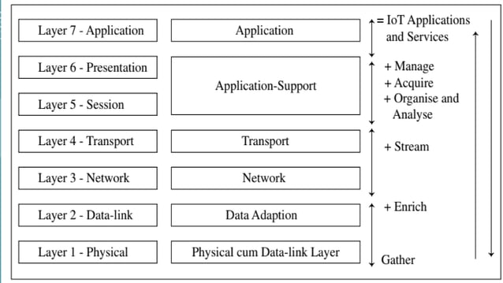

## [**Design Standardization**](https://bcalabs.org/subject/iot-m2m-systems-layers-and-design-standardization-in-iot#Design%20Standardization)

* Design standardization in IoT refers to the development and adoption of common technical specifications,
* protocols, and guidelines to ensure **compatibility and interoperability**among various IoT devices and systems.
* This standardization facilitates**seamless communication and integration**
* between devices from **different manufacturers,** enabling them to work together effectively.

### [**Communication Protocols**](https://bcalabs.org/subject/iot-m2m-systems-layers-and-design-standardization-in-iot#Communication%20Protocols)

* Standardized communication protocols, such as **HTTP,**
* are essential for enabling seamless data exchange between IoT devices from different manufacturers.
* Regardless of their origin, thereby facilitating a unified and efficient IoT ecosystem.

### [**Data Formats**](https://bcalabs.org/subject/iot-m2m-systems-layers-and-design-standardization-in-iot#Data%20Formats)

* Standardizing data formats and structures allows for consistent data interpretation and processing across various devices and platforms.
* This means that data generated by one device can be easily understood
* and utilized by another, and simplifying data integration and analysis.

### [**Security Standards**](https://bcalabs.org/subject/iot-m2m-systems-layers-and-design-standardization-in-iot#Security%20Standards)

* Implementing uniform security measures is crucial for protecting IoT systems against threats.
* Standardized security protocols, such as encryption, authentication,
* and access control, ensure that all devices within the network adhere to the same security practices.

### [**Hardware Interfaces**](https://bcalabs.org/subject/iot-m2m-systems-layers-and-design-standardization-in-iot#Hardware%20Interfaces)

* Standardized hardware interfaces and connectors ensure that different sensors, actuators, and devices can be easily integrated into various IoT systems.
* This compatibility simplifies the deployment and maintenance of IoT infrastructure, allowing for more flexible and scalable solutions.

### [**Interoperability Guidelines**](https://bcalabs.org/subject/iot-m2m-systems-layers-and-design-standardization-in-iot#Interoperability%20Guidelines)

* Developing guidelines and best practices for interoperability ensures that
* devices and systems from different manufacturers can work together without conflicts.
* These guidelines help in achieving a cohesive and functional IoT ecosystem.

### [**What do you mean by Communicational Technology ?**](https://bcalabs.org/subject/iot-m2m-systems-layers-and-design-standardization-in-iot#What%20do%20you%20mean%20by%20Communicational%20Technology%20?)

* Communicational technology refers to the various methods, protocols, and
* systems used to enable data exchange between IoT devices, networks, and platforms.
* These technologies are crucial for ensuring that IoT devices can effectively
* communicate with each other, share data, and interact with centralized systems for analysis and control.

### [**Key aspects of communicational technology in IoT**](https://bcalabs.org/subject/iot-m2m-systems-layers-and-design-standardization-in-iot#Key%20aspects%20of%20communicational%20technology%20in%20IoT)

#### [Wireless Communication Protocols](https://bcalabs.org/subject/iot-m2m-systems-layers-and-design-standardization-in-iot#Wireless%20Communication%20Protocols)

* Wireless protocols such as **Wi-Fi, Bluetooth, Zigbee, Z-Wave, LoRaWAN**, and**NB-IoT** enable IoT devices to communicate without physical connections.
* These protocols vary in range, power consumption, and data rates, catering to different IoT applications.
* For example, Bluetooth is suitable for short-range, low-power communication,
* while LoRaWAN supports long-range, low-power communication ideal for wide-area networks.

#### [Wired Communication Protocols](https://bcalabs.org/subject/iot-m2m-systems-layers-and-design-standardization-in-iot#Wired%20Communication%20Protocols)

* Wired protocols, like **Ethernet and serial communication (RS-232, RS-485**), provide reliable, secure, and high-speed data transfer.
* They are often used in industrial and high-stakes environments where
* stability and security are paramount, such as factory automation and critical infrastructure.

#### [Low-Power Wide-Area Networks (LPWAN)](https://bcalabs.org/subject/iot-m2m-systems-layers-and-design-standardization-in-iot#Low-Power%20Wide-Area%20Networks%20(LPWAN))

* LPWAN technologies like Sigfox, LoRaWAN, and NB-IoT are designed for long-range communication with minimal power consumption.
* These networks are ideal for IoT applications that require devices to operate on battery power for years,
* such as **environmental monitoring, smart agriculture**, and remote asset tracking.
* LPWANs support low data rates but cover extensive areas, making them suitable for scattered or rural deployments.

#### [Edge and Fog Computing](https://bcalabs.org/subject/iot-m2m-systems-layers-and-design-standardization-in-iot#Edge%20and%20Fog%20Computing)

* Edge computing processes data on the device or nearby, while fog computing processes data within a local network of devices.
* Both methods reduce the need to send data to a central cloud server, lowering latency and bandwidth usage.
* This approach is beneficial for real-time applications, such as autonomous vehicles and industrial automation, where quick data processing is crucial.

### [**What do you mean by data enrichment ?**](https://bcalabs.org/subject/iot-m2m-systems-layers-and-design-standardization-in-iot#What%20do%20you%20mean%20by%20data%20enrichment%20?)

* Data enrichment in the Internet of Things (IoT) refers to the process of enhancing raw data collected from IoT devices by adding context,
* meaning, and additional information to **make it more valuable and useful**for analysis and decision-making.
* This can involve combining the r**aw data with other data sources,**applying algorithms, or using metadata to provide deeper insights.

### [**Key aspects of data enrichment in IoT**](https://bcalabs.org/subject/iot-m2m-systems-layers-and-design-standardization-in-iot#%20Key%20aspects%20of%20data%20enrichment%20in%20IoT)

#### [Contextualization](https://bcalabs.org/subject/iot-m2m-systems-layers-and-design-standardization-in-iot#Contextualization)

* Adding **contextual information s**uch as time, location, or environmental conditions to the raw data to make it more meaningful.
* For example, temperature readings from sensors are more valuable when paired with the exact time and location of the measurement.

#### [Integration with External Data](https://bcalabs.org/subject/iot-m2m-systems-layers-and-design-standardization-in-iot#Integration%20with%20External%20Data)

* Combining IoT data with external data sources, such as weather data, traffic information, or social media feeds,
* to provide a more comprehensive understanding of the situation.

#### [Data Aggregation](https://bcalabs.org/subject/iot-m2m-systems-layers-and-design-standardization-in-iot#Data%20Aggregation)

* Summarizing or aggregating data from multiple IoT devices to identify trends or patterns.
* For instance, aggregating energy usage data from multiple smart meters
* can help in analyzing overall energy consumption patterns in a neighborhood.

#### [Application of Algorithms](https://bcalabs.org/subject/iot-m2m-systems-layers-and-design-standardization-in-iot#Application%20of%20Algorithms)

* Using machine learning and other algorithms to analyze and interpret the data,
* identifying anomalies, predicting future events, or providing actionable insights.
* For example, predictive maintenance algorithms can analyze data from machinery sensors to predict when maintenance is needed.

#### [Adding Metadata](https://bcalabs.org/subject/iot-m2m-systems-layers-and-design-standardization-in-iot#Adding%20Metadata)

* Enhancing raw data with metadata, which provides additional details about the data, such as the source, format, or quality.
* Metadata helps in organizing, searching, and understanding the data more effectively.

### [**What do you mean by data consolidation ?**](https://bcalabs.org/subject/iot-m2m-systems-layers-and-design-standardization-in-iot#What%20do%20you%20mean%20by%20data%20consolidation%20?)

* Data integration is the process of combining data from multiple sources into a unified database.
* This process is essential for achieving a comprehensive view of the data, improving data quality, and enabling more effective analysis.
* In Internet of Things (IoT), data consolidation involves aggregating data
* collected from various IoT devices, sensors, and systems into a centralized database or data warehouse.

### [**Key aspects of data consolidation**](https://bcalabs.org/subject/iot-m2m-systems-layers-and-design-standardization-in-iot#Key%20aspects%20of%20data%20consolidation)

#### [Data Aggregation](https://bcalabs.org/subject/iot-m2m-systems-layers-and-design-standardization-in-iot#Data%20Aggregation)

* Gathering data from different IoT devices and sources, such as sensors, machines, and external databases, and combining it into a single dataset.
* This step ensures that all relevant data is available in one place for analysis.

#### [Data Cleaning](https://bcalabs.org/subject/iot-m2m-systems-layers-and-design-standardization-in-iot#Data%20Cleaning)

* Identifying and correcting errors, inconsistencies, and duplicates in the collected data.
* Data cleaning is crucial to ensure that the consolidated dataset is accurate, reliable, and ready for analysis.

#### [Data Transformation](https://bcalabs.org/subject/iot-m2m-systems-layers-and-design-standardization-in-iot#Data%20Transformation)

* Converting data from different formats and structures into a standardized format.
* This step ensures that data from various sources can be easily integrated and compared within the unified dataset.

#### [Data Integration](https://bcalabs.org/subject/iot-m2m-systems-layers-and-design-standardization-in-iot#Data%20Integration)

* Merging data from different sources while preserving its integrity and consistency.
* Data integration often involves resolving conflicts and discrepancies between datasets to create a cohesive and accurate consolidated dataset.

#### [Data Storage](https://bcalabs.org/subject/iot-m2m-systems-layers-and-design-standardization-in-iot#Data%20Storage)

* Storing the consolidated data in a centralized repository, such as a data warehouse or cloud storage.
* This repository provides a single source of truth for the data, making it easier to access, manage, and analyze.

### [**How can we differentiate between data enrichment and consolidation**](https://bcalabs.org/subject/iot-m2m-systems-layers-and-design-standardization-in-iot#How%20can%20we%20differentiate%20between%20data%20enrichment%20and%20consolidation)

Data enrichment and data consolidation are two distinct processes in data management, each serving a different purpose:

#### [Data Enrichment](https://bcalabs.org/subject/iot-m2m-systems-layers-and-design-standardization-in-iot#Data%20Enrichment)

* Enhances existing data by adding more information to make it more valuable and insightful.
* Involves adding context, integrating external data, applying algorithms, and attaching metadata.
* Combining temperature sensor data with weather reports to provide context for the readings.

#### [Data Consolidation](https://bcalabs.org/subject/iot-m2m-systems-layers-and-design-standardization-in-iot#Data%20Consolidation)

* Merges data from various sources into a single, cohesive dataset.
* Involves aggregating, cleaning, transforming, integrating, and storing data.
* Merging data from multiple sensors in different locations into a central database.

#### [Key Differences](https://bcalabs.org/subject/iot-m2m-systems-layers-and-design-standardization-in-iot#Key%20Differences)

* Enrichment is about enhancing and adding value to data, while consolidation is about combining and unifying data.
* Enriched data provides deeper insights, whereas consolidated data provides a comprehensive dataset from multiple sources.

### [**What do you mean by ease of designing and affordability in IOT?**](https://bcalabs.org/subject/iot-m2m-systems-layers-and-design-standardization-in-iot#What%20do%20you%20mean%20by%20ease%20of%20designing%20and%20affordability%20in%20IOT?)

#### [Ease of Designing](https://bcalabs.org/subject/iot-m2m-systems-layers-and-design-standardization-in-iot#Ease%20of%20Designing)

* The concept of ease of designing in IoT (Internet of Things) pertains to the simplicity,
* efficiency, and user-friendliness of the design process for IoT solutions. Here's how it applies:

#### [Intuitive Design Tools](https://bcalabs.org/subject/iot-m2m-systems-layers-and-design-standardization-in-iot#Intuitive%20Design%20Tools)

* Design tools specific to IoT, such as IoT development platforms and integrated development environments (IDEs), should be intuitive and user-friendly.
* These tools should simplify the process of creating IoT applications, enabling designers to easily prototype, iterate, and refine their ideas.

#### [Modular and Reusable Components](https://bcalabs.org/subject/iot-m2m-systems-layers-and-design-standardization-in-iot#Modular%20and%20Reusable%20Components)

* Designing IoT solutions becomes easier when designers can leverage modular and reusable components.
* This allows them to quickly assemble and integrate various hardware and software modules to create custom IoT devices and applications without starting from scratch.

#### [Prototyping and Simulation](https://bcalabs.org/subject/iot-m2m-systems-layers-and-design-standardization-in-iot#Prototyping%20and%20Simulation)

* Ease of designing IoT solutions is enhanced through tools that support rapid prototyping and simulation.
* Designers can create virtual prototypes of IoT devices and systems, simulate their behavior in different scenarios.

#### [Visualization and Interface Design](https://bcalabs.org/subject/iot-m2m-systems-layers-and-design-standardization-in-iot#Visualization%20and%20Interface%20Design)

* Visualization tools and interface design frameworks play a crucial role in IoT design.
* Designers should have access to tools that allow them to create intuitive user interfaces and visualize data from IoT devices in a clear and actionable manner, enhancing the overall user experience.

#### [Collaboration and Integration](https://bcalabs.org/subject/iot-m2m-systems-layers-and-design-standardization-in-iot#Collaboration%20and%20Integration)

* Collaboration tools and integration capabilities facilitate teamwork among designers, developers, engineers, and stakeholders involved in IoT projects.
* Designers should be able to seamlessly collaborate, share ideas, and integrate their work with other team members' contributions to ensure cohesion and alignment throughout the design process.

#### [Documentation and Support](https://bcalabs.org/subject/iot-m2m-systems-layers-and-design-standardization-in-iot#Documentation%20and%20Support)

* Comprehensive documentation and support resources are essential for designers working on IoT projects.
* Access to tutorials, guidelines, reference materials, and community forums can help designers navigate challenges.

#### [Affordability](https://bcalabs.org/subject/iot-m2m-systems-layers-and-design-standardization-in-iot#Affordability)

* In Internet of Things (IoT), affordability refers to the cost-effectiveness of IoT solutions, devices, and infrastructure.
* It encompasses several aspects related to the financial accessibility and sustainability of IoT implementations.

#### [Cost-Effective Solutions](https://bcalabs.org/subject/iot-m2m-systems-layers-and-design-standardization-in-iot#Cost-Effective%20Solutions)

* IoT solutions should be designed and developed with a focus on minimizing costs without compromising quality, performance, or security.
* This involves optimizing hardware, software, and deployment processes to reduce expenses associated with manufacturing, installation, maintenance, and operation.

#### [Affordable Devices and Components](https://bcalabs.org/subject/iot-m2m-systems-layers-and-design-standardization-in-iot#Affordable%20Devices%20and%20Components)

* IoT devices, sensors, and components should be **affordable and accessible** to a wide range of users, including individuals, businesses, and organizations with varying budgets and resources.
* This may involve leveraging cost-effective materials, **manufacturing techniques,** and supply chains to keep production costs low.

#### [Scalability and Cost Efficiency](https://bcalabs.org/subject/iot-m2m-systems-layers-and-design-standardization-in-iot#Scalability%20and%20Cost%20Efficiency)

* IoT deployments should be scalable and cost-efficient, allowing for incremental expansion and growth without significant increases in expenses.
* This includes designing systems that can **accommodate additional devices,** users, and data volume without substantial investments in infrastructure or resources.

#### [Energy Efficiency](https://bcalabs.org/subject/iot-m2m-systems-layers-and-design-standardization-in-iot#Energy%20Efficiency)

* Affordability in IoT also involves minimizing energy consumption and operational costs associated with IoT devices and networks.
* Energy-efficient designs,**low-power components, and optimized communication protocols** help reduce electricity bills and extend the lifespan of battery-powered devices.

#### [Total Cost of Ownership (TCO)](https://bcalabs.org/subject/iot-m2m-systems-layers-and-design-standardization-in-iot#Total%20Cost%20of%20Ownership%20(TCO))

* Affordability considerations in IoT extend beyond initial purchase costs to include the total cost of ownership over the device or solution's lifecycle.
* This encompasses ongoing expenses such as **maintenance, upgrades, software updates,** data storage, and support services.

## [**Conclusion**](https://bcalabs.org/subject/iot-m2m-systems-layers-and-design-standardization-in-iot#Conclusion)

We have explored IoT/M2M systems layers and design standardization, Communication technologies, Data enrichment and consolidation, Ease of designing and affordability.

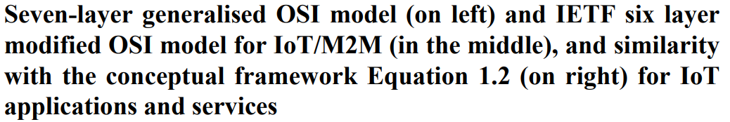

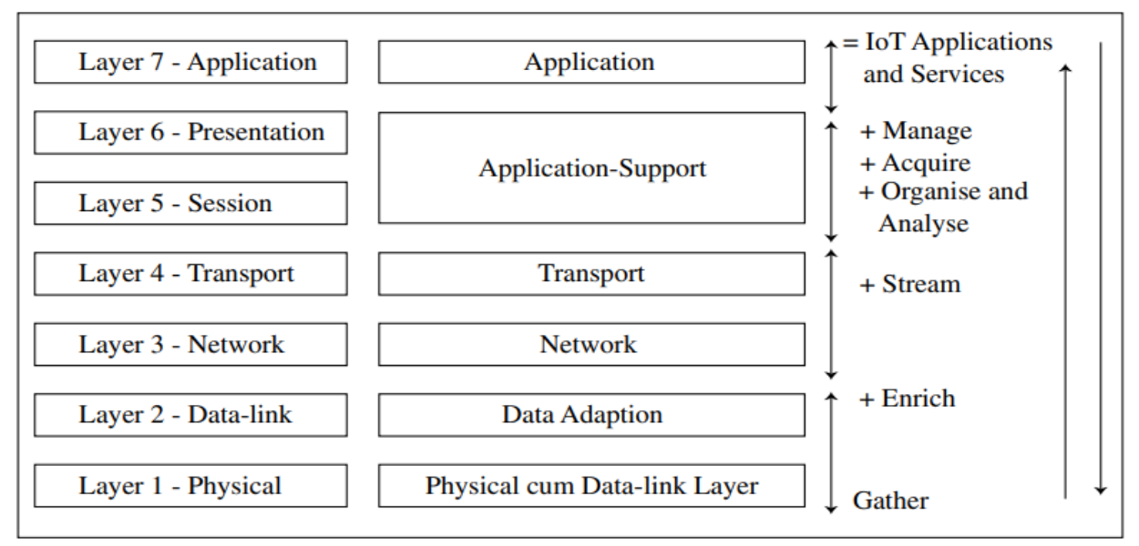

Certainly! [The **Modified OSI Model for IoT/M2M Systems** adapts the traditional OSI model to suit the unique requirements of the Internet of Things (IoT) and Machine-to-Machine (M2M) communication1](https://snscourseware.org/snscenew/files/1678862193.pdf). Here’s a brief overview:

1. **Physical Devices (Layer 1)**: This layer corresponds to the physical devices in an IoT system. It includes sensors, actuators, and other connected devices. These devices collect data and interact with the environment.
2. **Data Link Layer (Layer 2)**: Responsible for data framing, error detection, and addressing. It ensures reliable communication between devices within the same network.
3. **Network Layer (Layer 3)**: Handles routing, addressing, and forwarding of data packets. It ensures efficient data transfer across different networks.
4. **Transport Layer (Layer 4)**: Manages end-to-end communication, flow control, and error recovery. It ensures reliable data exchange between devices.
5. **Session Layer (Layer 5)**: Establishes, maintains, and terminates communication sessions. It handles session management and synchronization.
6. **Application Layer (Layer 6)**: At the top of the stack, this layer deals with application-specific protocols, data representation, and user interactions. It includes applications that people use to interact with IoT technology.

Remember that each layer has specific tasks, contributing to the efficiency, security, and reliability of IoT systems.

***ETSI M2M high-level architecture***

**IoT domain model**

Domain model as a description of concepts belonging to a particular area of interest. ¬ The domain model also defines basic attributes of these concepts, such as name and identifier. ¬ The domain model defines relationships between concepts, for instance “Services expose Resources”. ¬ Domain models also help to facilitate the exchange of data between domains. ¬ The main purpose of a domain model is to generate a common understanding of the target domain in question. ¬ The domain model is an important part of any reference model since it includes a definition of the main abstract concepts (abstractions), their responsibilities, and their relationships. ¬ The domain model captures the basic attributes of the main concepts and the relationship between these concepts

**high-level architecture**

This high-level architecture is a combination of both a functional and topological view showing some functional groups (FG) clearly associated with pieces of physical infrastructure (e.g. M2M Devices, Gateways). ¬ There are two main domains, a network domain and a device and gateway domain. ¬ The boundary between these conceptually separated domains is the topological border between the physical devices and gateways and the physical communication infrastructure (Access network).

This is the device of interest for an M2M scenario, for example, a device with a temperature sensor.

• An M2M Device contains M2M Applications and M2M Service Capabilities.

• An M2M device connects to the Network Domain either directly or through an M2M Gateway:

• Direct connection: The M2M Device is capable of performing registration, authentication, authorization, management, and provisioning to the Network Domain. Direct connection also means that the M2M device contains the appropriate physical layer to be able to communicate with the Access Network.

• Through one or more M2M Gateway:

M2M device does not have the appropriate physical layer, compatible with the Access Network technology, and

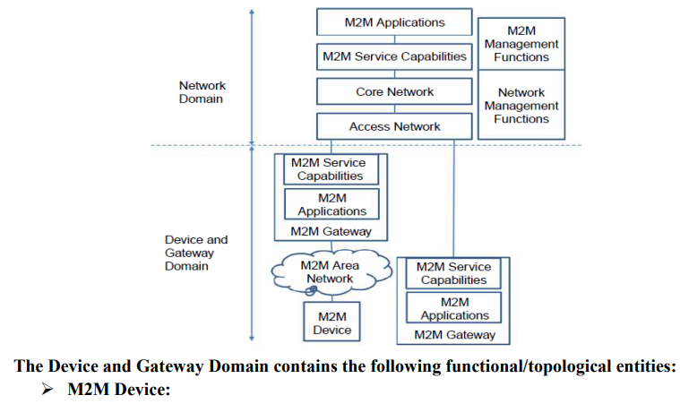

***Communication Technologies:***

***Communication model***

***The communication model for an IoT Reference Model consists of the identification of the endpoints of interactions, traffic patterns (e.g. unicast vs. multicast), and general properties of the underlying technologies used for enabling such interactions. ¬***

***It is used to identification of the endpoints of the communication paths. ¬ The potential communicating endpoints or entities are the Users, Resources, and Devices from the IoT Domain Model.***

***¬ Users include Human Users and Active Digital Artifacts (Services, internal system components, external applications).***

***¬ Devices with a Human\_Machine Interface mediate the interactions between a Human User and the physical world (e.g. keyboards, mice, pens, touch screens, buttons, microphones, cameras, eye tracking, and brain wave interfaces, etc.), and therefore the Human User is not a communication model endpoint.***

***¬ The User (Active Digital Artifact, Service)-to-Service interactions include the User-toService and Service-to-Service interactions as well as the Service\_Resource\_Device interactions.***

***¬ The User-to-Service and Service-to-Service communication is typically based on Internet protocols and one or both Services are hosted in Service-to-Service interactions on constrained/low-end Devices such as embedded systems.***

***¬ The communication model for these interactions includes several types of gateways (e.g. network, application layer gateways) to bridge between two or more disparate communication technologies.***

***¬ The Devices may be so constrained that they cannot host the Services, while the Resources could be hosted or not depending on the Device capabilities.***

***¬ This inability of the Device to host Resources or Services results in moving the corresponding Resources and/or Services out of the Device and into more powerful Devices or machines in the cloud.***

***¬ Then the Resource-to-Device or the Service-to-Resource communication needs to involve multiple types of communication stacks.***

***What is Data Enrichment ?***

***Having good and wide-ranging information is crucial for making informed decisions, especially with the vast amount of data available. To make raw data more valuable, we often rely on a process called data enrichment. This process gives us a more complete view of the data, which can result in better analyses and smarter decision-making.***

***This article will explain Data Enrichment to those unfamiliar with it and how it turns data into a useful resource.***

***Table of Content***

* [***What is Data Enrichment?***](https://www.geeksforgeeks.org/what-is-data-enrichment/#what-is-data-enrichment)
* [***Why is data enrichment important?***](https://www.geeksforgeeks.org/what-is-data-enrichment/#why-is-data-enrichment-important)
* [***How to implement data enrichment?***](https://www.geeksforgeeks.org/what-is-data-enrichment/#how-to-implement-data-enrichment)
* [***Examples of Data Enrichment***](https://www.geeksforgeeks.org/what-is-data-enrichment/#examples-of-data-enrichment)
* [***Conclusion***](https://www.geeksforgeeks.org/what-is-data-enrichment/#conclusion)

***What is Data Enrichment?***

***The practice of adding more information to raw data to make it more complete and thorough is known as data enrichment. It entails enhancing accuracy, adding pertinent features, and closing gaps to increase the data’s analytical value. Through this process, simple knowledge is transformed into a rich resource that may provide greater understanding. It may assist you in improved decision-making, process optimization, product improvement, and consumer understanding. But raw data on its own is insufficient. To make your data more relevant and helpful, you must add more details and insights to it. This post will define data enrichment, discuss its significance, and provide implementation guidelines.***

***The goal of data enrichment is to enhance your data with more context and details so that you can get a deeper understanding of your customers, markets, trends, and opportunities. Data enrichment can help you answer more questions, generate more insights, and create more value from your data.***

***Why is data enrichment important?***

***Data enrichment can provide many benefits for your business or organization, such as:***

1. ***Personalization: You may better cater your goods, services, and marketing to the tastes, requirements, and actions of your target audience by using data enrichment. Personalized offers, recommendations, and messages may be sent to clients based on their demographics, interests, geography, and past purchases, for instance, by using data enrichment to segment your customer base.***
2. ***Customer experience: Data enrichment can help you to enhance customer satisfaction and loyalty may be achieved through data enrichment by offering superior service and support. Data enrichment, for instance, may be used to pinpoint the concerns, suggestions, and expectations of your clients so that you can proactively and successfully address them.***
3. ***Better Decision-Making: Enriched data provides a complete understanding of the subject, enabling organizations to make more informed decisions.***
4. ***Targeted Marketing: Enriched data allows businesses to better understand their target audience, leading to more effective and personalized marketing strategies.***
5. ***Performance: With more precise and dependable data at your disposal, data enrichment may help you enhance your operations and procedures. To enhance your data analysis and reporting, for instance, you may utilize data enrichment to eliminate mistakes, duplication, and inconsistencies in your data.***
6. ***Improved Accuracy: By adding missing details and correcting errors, Data Enrichment enhances the accuracy of the dataset, reducing the risk of misinformation.***
7. ***Innovation: Data enrichment can help you discover new opportunities and solutions by providing you with more diverse and comprehensive data. Data enrichment, for instance, may be used to discover new markets, trends, and patterns in your data, from which you can create new features, products, and business plans.***

***How to implement data enrichment?***

***Depending on your data sources, objectives, and available technologies, there are several approaches to data enrichment. The following are some general actions to take:***

1. ***Identify your data needs: You must decide what sort of information and why you wish to add it to your data before you can begin the process of enriching it. For instance, you could wish to add social media profiles of your customers or reviews and ratings to your product data to enhance it. To assess the effectiveness of your data enrichment procedure, you must also define the metrics and criteria.***
2. ***Find your data sources: Finding the finest sources to add to your data is the next step. These can come from third-party sources like public databases, APIs, or web scraping, or from internal or external sources like your own databases, CRM systems, or web analytics. You must assess each source’s quality, applicability, and accessibility before selecting the ones that best meet your data requirements.***
3. ***Integrate your data sources: The next step is to combine your new and current data sets with your data sources. There are several ways to accomplish this, including matching, combining, appending, and modifying your data. You must verify if your data adheres to your data standards and rules and is compatible, consistent, and compliant.***
4. ***Enrich your data: Finally, With the additional information from your data sources, you must enhance your data. A variety of techniques, including data enrichment, data analysis, and data visualization software, can be used to do this. To enrich your data, you must use the proper methods, such as data validation, data cleansing, data augmentation, or data improvement.***

***Examples of Data Enrichment***

***The process of adding additional and extra information to raw data and cross-referencing it with information from other sources is known as data enrichment. This increases the original data’s quality and value. Data analysis, machine learning, and data visualization may all benefit from data enrichment. I’ll give you two instances of data enrichment with Python code in my response.***

***Example 1: Data Enrichment with Synthetic Dataset***

***I generated a synthetic dataset for the first example using Scikit-Learn2’s make\_classification function. A random two-class classification issue with two features is produced by this function. The 1000 samples in the artificial dataset look like this:***

* ***Python3***

|  |
| --- |
| ***import numpy as np***  ***import pandas as pd***  ***from sklearn.datasets import make\_classification***  ***import matplotlib.pyplot as plt***    ***# Generate synthetic dataset***  ***X, y = make\_classification(***  ***n\_samples=1000,***  ***n\_features=2,***  ***n\_redundant=0,***  ***n\_clusters\_per\_class=1,***  ***random\_state=42***  ***)***    ***# Convert to pandas dataframe***  ***df = pd.concat([pd.DataFrame(X), pd.Series(y)], axis=1)***  ***df.columns = ['x1', 'x2', 'y']***    ***# Print first 5 rows***  ***print(df.head())*** |

***Output:***

***x1 x2 y***

***0 0.601034 1.535353 1***

***1 0.755945 -1.172352 0***

***2 1.354479 -0.948528 0***

***3 3.103090 0.233485 0***

***4 0.753178 0.787514 1***

***I’ll add some noise to the features, combine the original features to produce a new feature, and then label the target variable to enrich this dataset. The new feature will introduce some non-linearity to the data, the noise will make the data more realistic and difficult to identify, and the labels will improve the data’s interpretability. The data enrichment code is:***

* ***Python3***

|  |
| --- |
| ***# Add noise to the features***  ***noise = np.random.normal(0, 0.1, size=(1000, 2))***  ***df['x1'] = df['x1'] + noise[:, 0]***  ***df['x2'] = df['x2'] + noise[:, 1]***    ***# Create a new feature that is a combination of the original features***  ***df['x3'] = df['x1'] \* df['x2']***    ***# Add labels to the target variable***  ***df['y'] = df['y'].map({0: 'Class A', 1: 'Class B'})***    ***# Print first 5 rows***  ***print(df.head())*** |

***Output:***

***x1 x2 y x3***

***0 0.542946 1.482836 Class B 0.805100***

***1 0.698807 -1.264760 Class A -0.883824***

***2 1.093224 -0.853491 Class A -0.933057***

***3 3.184734 0.081097 Class A 0.258273***

***4 0.710373 0.713274 Class B 0.506690***

***The enriched dataset has more information and complexity than the original dataset. To visualize the data, I will use the Matplotlib library to plot the features and the target variable. The code for data visualization is:***

* ***Python3***

|  |
| --- |
| ***# Plot the features and the target variable***  ***plt.figure(figsize=(14, 7))***  ***plt.scatter(x=df[df['y'] == 'Class A']['x1'], y=df[df['y'] == 'Class A']['x2'], label='Class A')***  ***plt.scatter(x=df[df['y'] == 'Class B']['x1'], y=df[df['y'] == 'Class B']['x2'], label='Class B')***  ***plt.xlabel('x1')***  ***plt.ylabel('x2')***  ***plt.legend()***  ***plt.show()*** |

***Output:***

***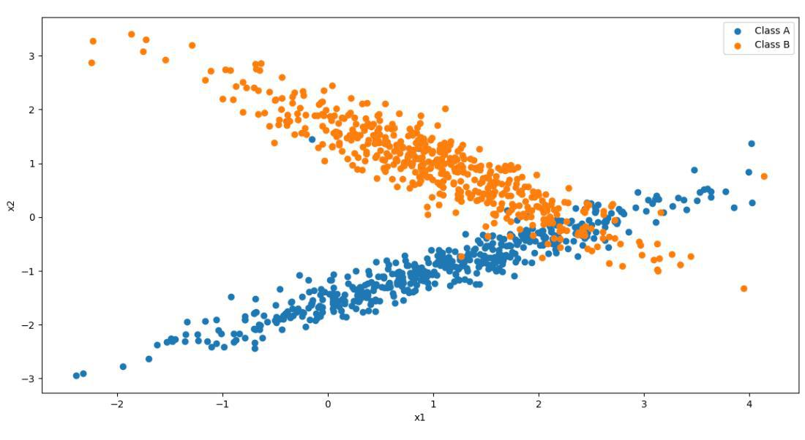***

***Example 2: Data Enrichment with a Public Dataset***

***In this example, we’ll use a public dataset (***[***Iris dataset***](https://www.geeksforgeeks.org/iris-dataset/)***) and demonstrate Data Enrichment by adding additional information.***

***Step 1: Import Necessary Libraries***

* ***Python3***

|  |
| --- |
| ***import pandas as pd***  ***import seaborn as sns***  ***import matplotlib.pyplot as plt*** |

***Step 2: Load the Public Dataset (Iris Dataset)***

* ***Python3***

|  |
| --- |
| ***# Load Iris dataset from seaborn library***  ***iris = sns.load\_dataset('iris')*** |

***Step 3: Visualize the Original Dataset***

* ***Python3***

|  |
| --- |
| ***# Pairplot for visualizing relationships in the original dataset***  ***sns.pairplot(iris, hue='species', markers=["o", "s", "D"])***  ***plt.suptitle("Pairplot of Original Iris Dataset")***  ***plt.show()*** |

***Output:***

***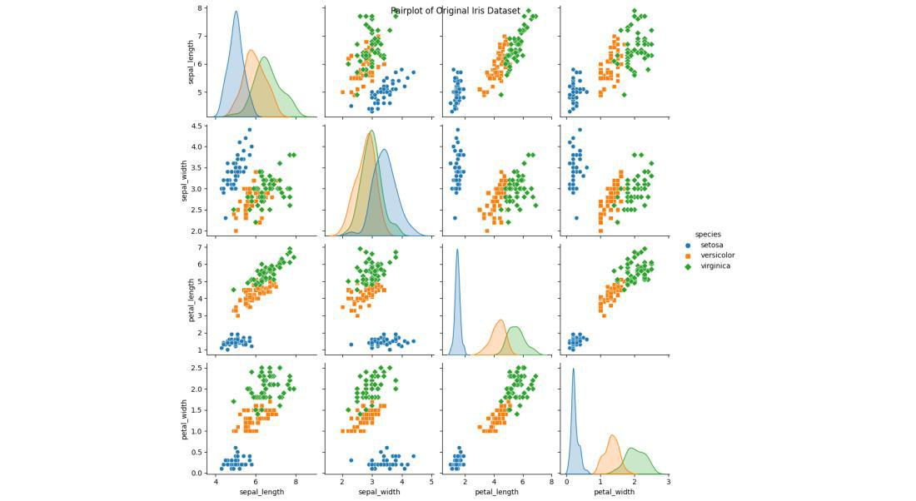***

***Step 4: Data Enrichment – Adding Petal Area Column***

* ***Python3***

|  |
| --- |
| ***# Calculate petal area and add it as a new column for data enrichment***  ***iris['petal\_area'] = iris['petal\_length'] \* iris['petal\_width']*** |

***Step 5: Visualize the Enriched Dataset***

* ***Python3***

|  |
| --- |
| ***# Pairplot to visualize relationships in the enriched dataset***  ***sns.pairplot(iris, hue='species', markers=["o", "s", "D"])***  ***plt.suptitle("Pairplot of Enriched Iris Dataset with Petal Area")***  ***plt.show()*** |

***Output:***

***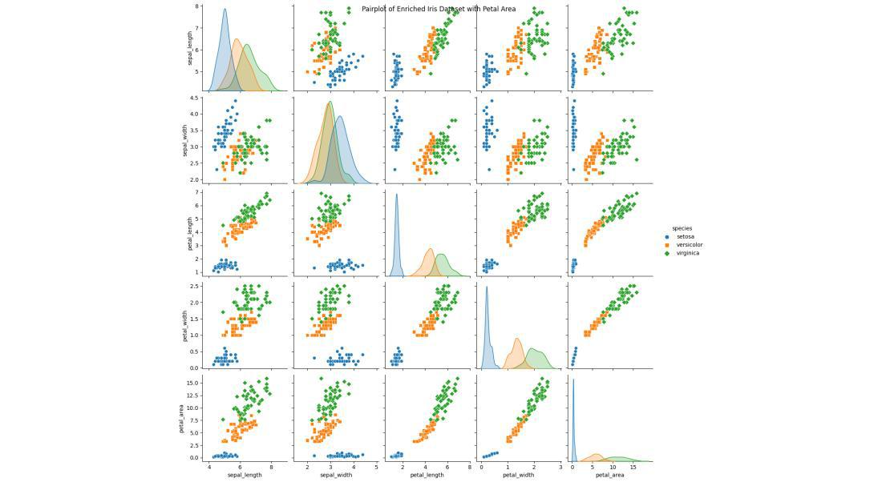***

***This example demonstrates Data Enrichment by adding a synthetic petal area column to the famous Iris dataset and visualizing the relationships in the original and enriched datasets.***

***Conclusion***

***In conclusion, Data Enrichment is a crucial process that elevates the quality and utility of data for various purposes. Organizations may use the potential of enhanced data to acquire a competitive edge and make more strategic decisions by using the procedures described in this article. By adding new and relevant information to your data, you can gain more insights, create more opportunities, and achieve more goals. You may enhance your client experience, boost productivity, develop new solutions, and tailor your goods, services, and marketing with the aid of data enrichment.***

**What is Data Consolidation? Overview & Techniques**

**What is Data Consolidation?**

**Data consolidation is the process of combining data from multiple sources, cleaning and verifying it by removing errors, and storing it in a single location, such as a**[**data warehouse**](https://www.astera.com/type/blog/data-warehouse-definition/)**or database. Data is produced from various sources and in multiple formats in every business. The data consolidation process makes it easier to unify that data.**

**Consolidating data enables companies to efficiently plan, implement, and execute business processes and disaster recovery solutions. This is done because all critical data in one place grants users a**[**360-degree view**](https://www.astera.com/type/blog/salesforce-integration-tools/)**of all their business assets. It improves data quality, fast-tracks process execution, and simplifies information access. Thus, proving how necessary data consolidation is.**

**Data consolidation differs from**[**data integration**](https://www.astera.com/type/blog/data-integration/)**in that it specifically emphasizes the process of merging and organizing data from multiple sources into a single, coherent dataset. On the other hand, integrating data encompasses a broader set of activities to create a unified view of data. In short, data consolidation is a subset of data integration, focusing on creating a consolidated and organized dataset from diverse data sources.**

**Consolidate Business Data With CDC And Job Scheduling Features**

[**SEE HOW IT'S DONE [](https://www.astera.com/astera-centerprise-demo/)**](https://www.astera.com/astera-centerprise-demo/)

**Data Consolidation Techniques**

**The following are the three most common data consolidation techniques:**

**ETL (Extract, Transform, Load)**

[**ETL**](https://www.astera.com/type/blog/etl/)**is one of the most widely used data management techniques for consolidating data. It is a process in which data is extracted from a source system and loaded into a target system after transformation (including data cleansing, aggregation, sorting, etc.).**

**Automation integration tools can carry out ETL in two ways:**

* **Batch processing: is suitable for running repetitive, high-volume data jobs.**
* **Real-time ETL: uses CDC (**[**Change Data Capture**](https://www.astera.com/solutions/technology-solutions/change-data-capture/)**) to transfer updated data to the target system in real-time.**

**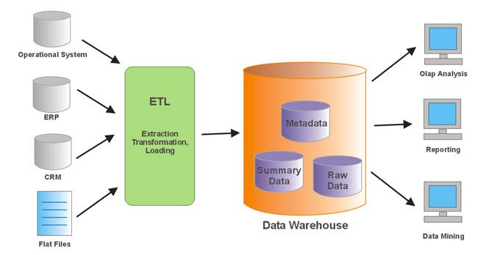**

**Source: Wisatakuliner**

**Data Virtualization**

**Data virtualization integrates data from heterogeneous data sources without replicating or moving it. It provides data operators with a consolidated, virtual view of information.**

**Unlike the ETL process, the data stays in its place but can be retrieved virtually by front-end solutions like applications, dashboards, and portals without knowing its specific storage site.**

**Data Warehousing**

[**Data warehousing**](https://www.astera.com/type/blog/what-is-data-warehousing/)**is the process of integrating data from disparate sources and storing it in a central repository. Hence, facilitating reporting, business intelligence, and other ad-hoc queries. It provides a broad, integrated view of all data assets, with relevant data clustered together.**

**Data gathered in a single place using a data consolidation tool makes it easier to determine trends and create business plans.**

**Looking For A User-Friendly Solution For Consolidating Data?**

[**GIVE ASTERA CENTERPRISE A TRY! [](https://www.astera.com/astera-centerprise-trial/)**](https://www.astera.com/astera-centerprise-trial/)

**Wrap Up**

**The data consolidation tasks offer businesses several benefits. When data is stored in one location, it requires a smaller setup for management. This allows companies to cut down their costs.**

**Moreover, by consolidating big data, you can enjoy better control as there are fewer processes involved in data retrieval, and you can access data directly from one place. This ensures significant time savings. Plus, planning, implementing, and executing disaster recovery solutions become comparatively more straightforward as all the critical data is in one location.**

**If you’re looking for an easy-to-use, user-friendly solution for consolidating data, give**[**Astera Centerprise a try**](https://astera.com/astera-centerprise-trial)**! It is more than just a**[**data integration tool**](https://www.astera.com/type/blog/data-integration-tools-for-businesses/)**that gives users the option to consolidate data using ETL, data virtualization, or data warehousing. You can select the technique that best fits your requirements.**

**What Is IoT Device Management?**

**IoT device management is defined as the collection of processes, tools, and technologies that help you provision, monitor, and maintain the growing sprawl of connected objects (also called the internet of things endpoints or edge devices) in your home or enterprise network.**

**As more and more devices come with network capabilities, the demand for IoT device management software is on the rise. According to the Cisco Annual Internet Report (2018–2023), there will be 29.3 billion networked devices by 2023 – that is, 3.6 devices for every person on the planet.**

**Two factors make IoT device management so important: pull and push.**

1. **There is a clear pull factor, as intelligent IoT device management paves the way for smarter analytics, more seamless automation, internal efficiencies, and innovative business models. Business models like servitization (where equipment is leased out and services are rendered based on IoT data instead of outright equipment sales) hinge on IoT device management.**

**Further, there is a push factor, as consumer adoption of connected devices is constantly growing. Without IoT device management, employees are likely to keep adding new endpoints to the organizational network, creating a massive shadow IT burden.**

**For these reasons, a 2020 research report by Valuates Reports indicates that the demand for IoT device management will grow at a 22.6% compound annual growth rate (CAGR) between 2021 and 2026. By the end of this forecast period, IoT device management will be a $6.25 billion market globally.**

**Ease of Designing and Affordability of IoT devices**

**Ease of Designing • Design for connected devices for IoT Applications, Services and business processes • Designer considers the ease in designing the devices physical, data link, adaption layers and gateway**

**Means availability of sensors, actuators, controllers and IoT devices • Low in cost and hardware • Use preferably open source software components and protocols**

**• Device hardware should embed minimum of components • Use ready solutions for ease in designing local devices personal area network • Ensure the secure connectivity with the Internet.**

**Affordability of IoT devices •**

**For example, RFID or card • The card: An embedded microcontroller, memory, OS, NFC peripheral interfaces, access point based device activation, RF module and transceiver and all that at low cost**

**• For example, Wireless sensors use Mote (mobile terminal) • Mote: Low cost devices with open source OS (tiny OS) and software components • Provides ease and affordance in the WSN networks.**

**Devices of smart homes and cities**

**• Use ZigBee IP or • BT LE 4.2 (dual mode or single mode) or WiFi • Due to their affordability, • Ease of designing, usage and low cost.**

**We learnt • Ease of designing with availability of sensors, actuators, controllers and IoT devices • Low in cost and hardware, and • Use preferably open source software components and protocols.**

**RFID or Mote ease availability makes them affordable Low in cost and hardware • Use of ZigBee IP or • BT LE 4.2 (dual mode or single mode) or WiFi due to standard protocols.**